**Lab Tutorial 02 - Tables and Forms**

**Question 1:**

Create an HTML document (*tablelinks.html*) to illustrate the use of table and hyperlinks as shown below:

Heading 1

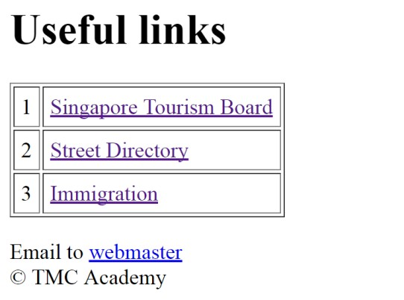

Link to https://[www.stb.gov.sg](http://www.stb.gov.sg/)

Link to [http://www.streetdirectory.com.sg](http://www.streetdirectory.com.sg/)

Link to https://[www.ica.gov.sg](http://www.ica.gov.sg/)

Send email to [webmaster@tmc.edu.sg](mailto:webmaster@tmc.edu.sg)

**Question 2:**

Create an HTML document (*table.html*) to illustrate the use of table with merged cells as shown below:

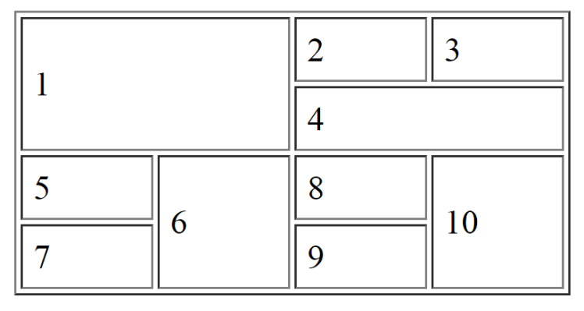

**Question 3:**

Create an HTML document (*register.html*) to illustrate the use of form elements as shown below:

rowspan=3

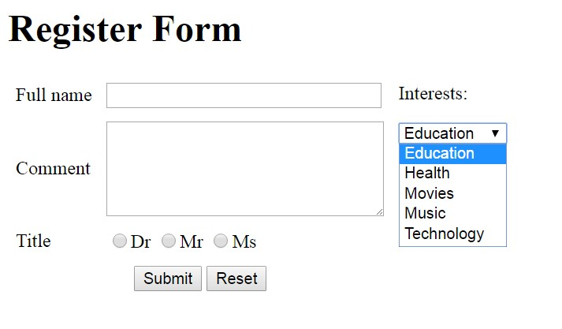

colspan=2

*Hint: Use of table (4 rows by 3 columns)* for arranging the form elements neatly*.*